**Deploy the application by using Jenkins:**

* Create the 4 ec2 instances on AWS .
* Connect to the Jenkins server and install the java and Jenkins.
* Log into the Jenkins dashboard and install the sonarqube scanner and docker to container plugin.
* Install the sonarqube on sonarqube server.
* Install the tomcat on tomcat server.

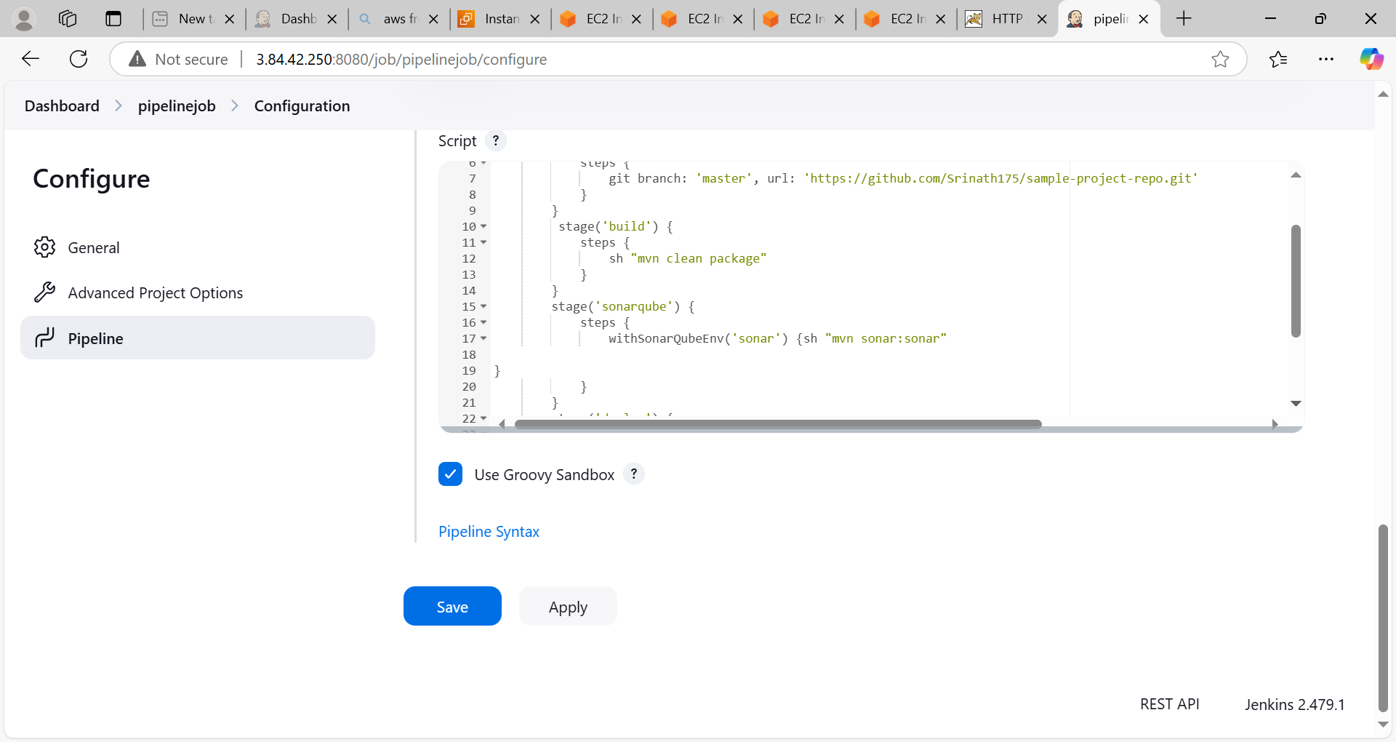

Jenkins pipeline success

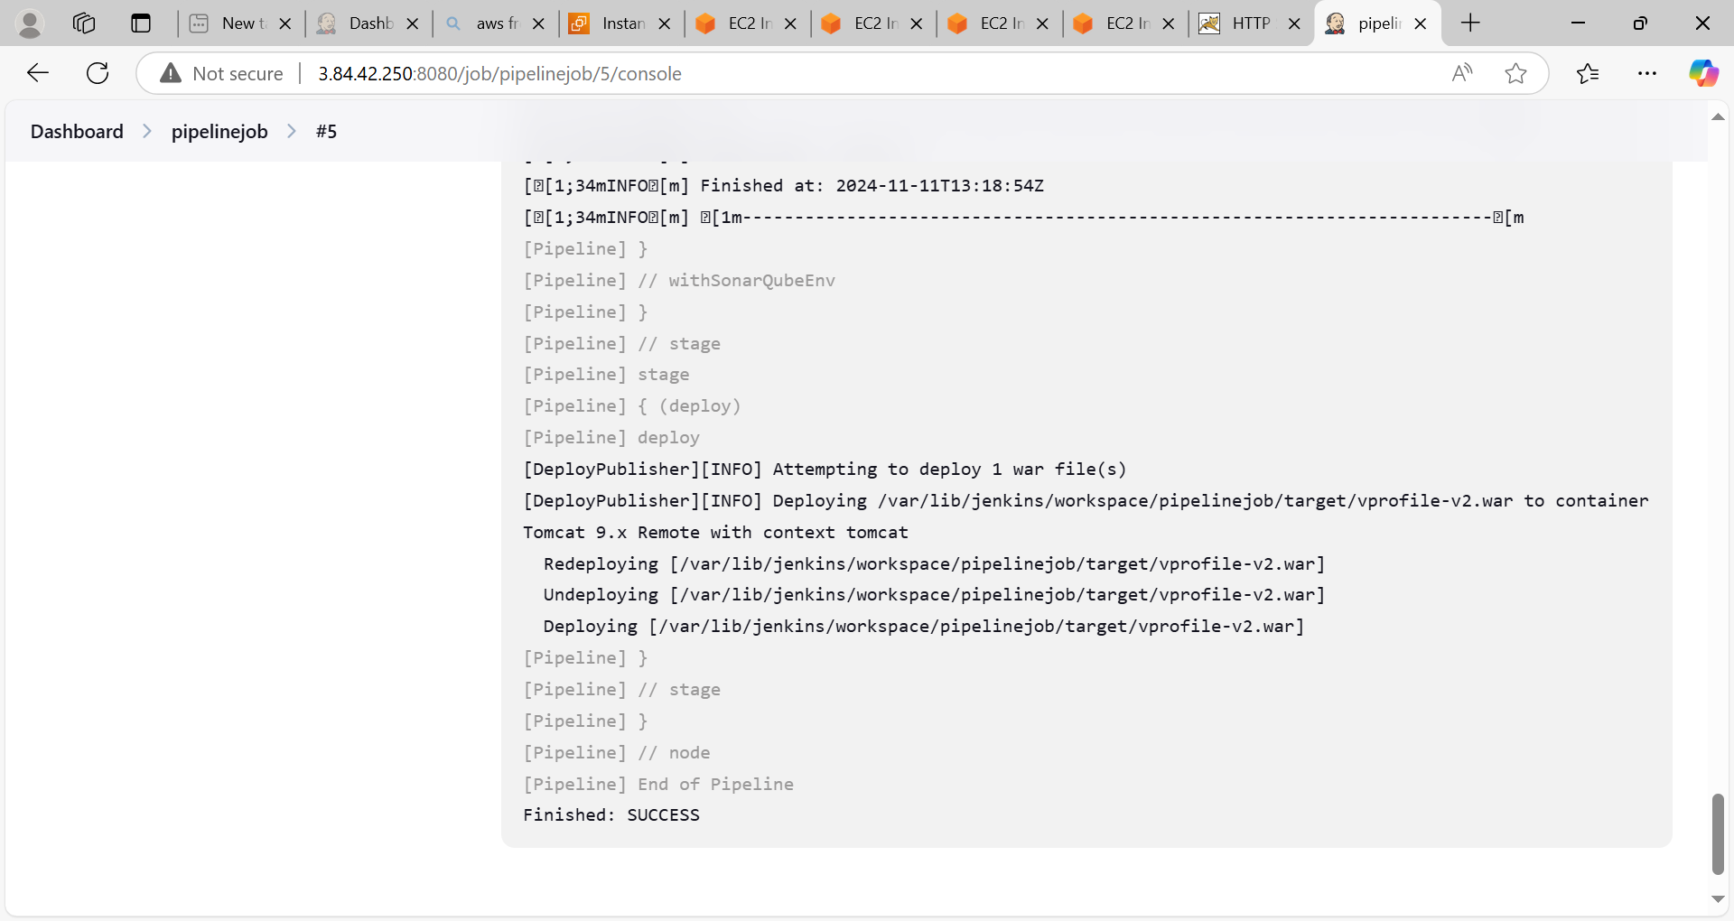

Code analysis by sonarqube

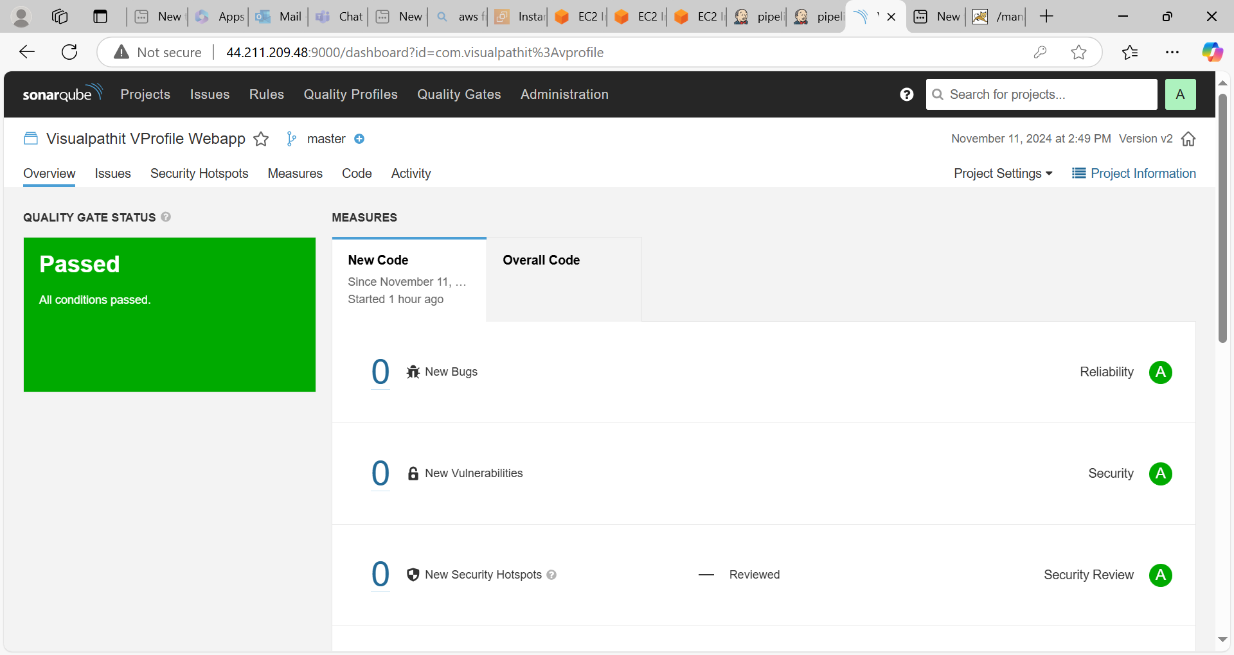

Access the application on tomcat

